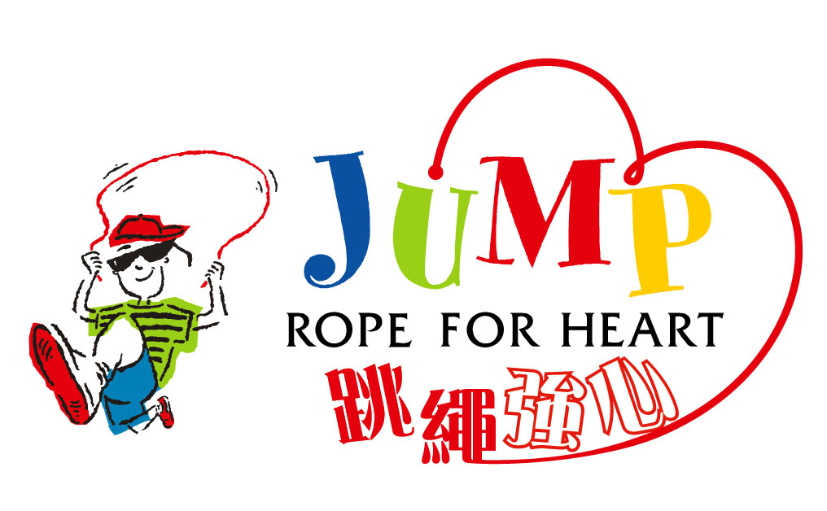
Record of Fund Raising (School) (2023-2024)
Page___of ____
established since 1999
School： |  | Class：
Teacher：

No. | Class | Fund raised  (HK$) | Cat. | JRFH Souvenirs
 |  |  |  | Ball Pen | Rope | Reusable Cutlery Set | Socks | Sports Towel | Rope Bag
 | Page Total
 | Class Total

Category | Fund raised | JRFH Souvenirs |  | Please make photocopies
1 | HK$50 | Ball Pen |  | (No need to tender this sheet to JRFH)
2 | HK$100 | Ball Pen + Rope
3 | HK$300 | Ball Pen + Rope + Reusable Cutlery Set + Socks
4 | HK$500 | Ball Pen + Rope + Reusable Cutlery Set + Socks + Sports Towel + Rope Bag |  | Teacher’s Signature：

